APPENDIX B
The HIGHLIGHTS of the trip include:
- Samsung D’ Light - Great place to experience a glimpse of the future and what Samsung Technology has impacted the technology world.
- MOU Signing with Korea Association of Property Appraisers (KAPA).
- An hour relaxation Mineral Hot Spring indulgence at the seaside – where you can soak away your stress and tiredness after a long flight (in house clothing is provided).
- Joyangbangjik Antique Cafe in Gangwha Island, Korea - this is one of the famous cafes, they turned the textile factory to a vintage cafe and has an amazing interior.
- Seaweed Museum with Gimbap making experience (to understand the nutrient behind this super food – a favourite of the Koreans).
- Noryangin Fish Market – a recently modernize wholesale fish market, where merchants prepare for the auction of fresh seafood in the early morning and seafood eatery is open in the evening. It is a favourite spot with the locals.
- Demilitarize Zone (DMZ) Tour - Head to Dora Observatory, and peer into the elusive North Korea with binoculars. Visit the Joint Security Area (JSA) and spot the United Nations building that straddles the border.
- Hyundai Motorstudio Goyang - The largest automobile theme park in Korea which opens this April. The establishment was built to have a look at how cars are created at Hyundai. It aims to show audiences that an automobile is more than just a mode of transportation.
- Lotte World Tower - The nation's tallest and the world's fifth tallest building, opened in 2017. Be mesmerize with its conceptual design, drawing inspiration from Korean ceramics and Korean writing brushes.
- The Musical Chef Show – A show full of energy, excitement and laughter! Musical CHEF! Set in a restaurant that serves Korean, Japanese and Chinese cuisine, two chefs begin a cook off to prove who's best. The cook off features live beatboxing and stunning b-boying. This fast, exciting, appetizing and out-of-this-world musical will keep the audiences on the edge of their seats!
- Seokchon Lake Cherry Blossom Festival - Get ready to fall in love with Seoul when you visit Seokchon Lake during springtime for that’s the best viewing site of Cherry Blossom in Seoul (this is the ONLY season)
- Sejong Story Exhibition Hall and King Sejong Statue - King Sejong, the 4th king of the Joseon Dynasty (1397-1450, reigning from 1418-1450) was responsible for some of the most brilliant achievements in the history of Korea, including the creation of Hangeul (Korean alphabet) and great advancements in the areas of science, culture, art and politics. The passage behind the Statue of King Sejong in Gwanghwamun Square is home to The Story of King Sejong Exhibition Hall, which describes some of the king’s most astounding contributions to the development of Korea as a nation.
- Red Pine and Cosmetic Duty Free Shopping Outlet – Explore and learn how the South Korea is the epicentre of new beauty technology.

FLIGHT SCHEDULE (AIR ASIA):
11/4/19 D7 504 KUL/ICN 0740/1520, 11/4/19
15/4/19 D7 509 ICN/KUL 2325/0455, 16/4/19
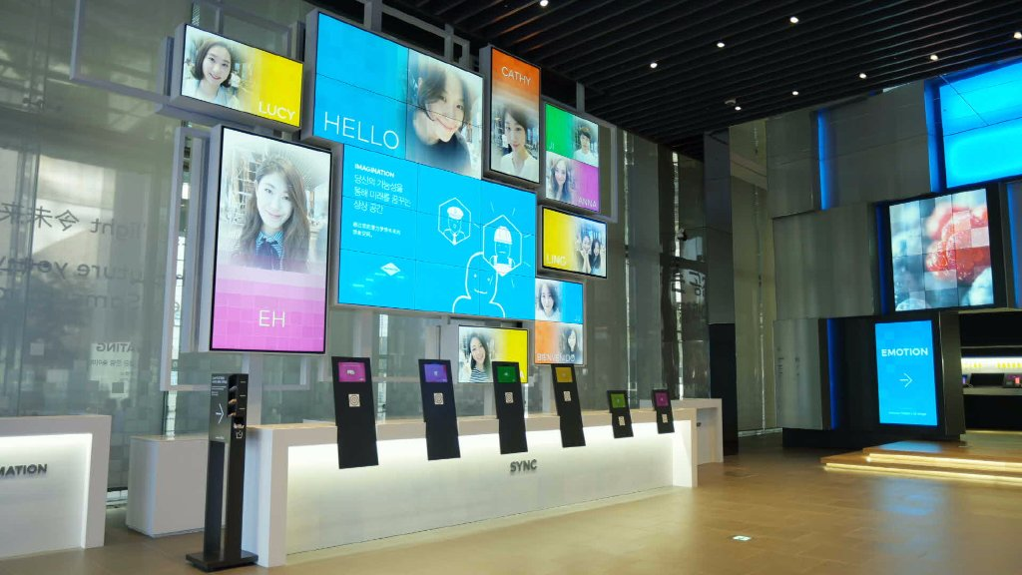 Samsung D’Light
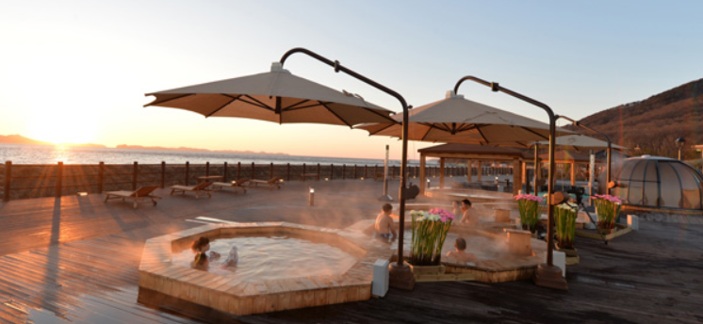 Mineral Hot Spring Indulgence
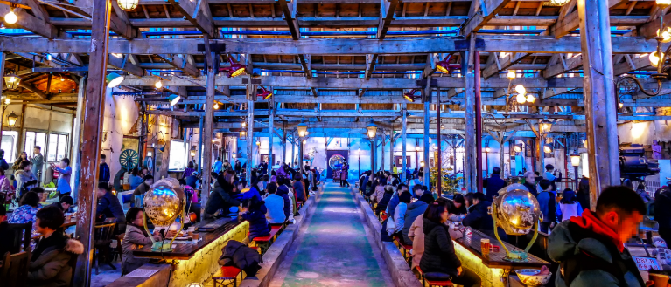 Joyangbangjik Antique Café
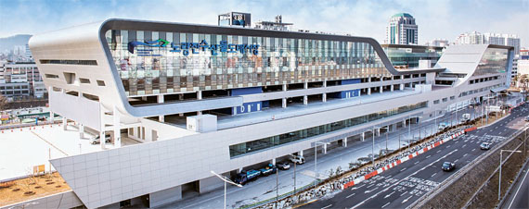 Noryangin Fish Market
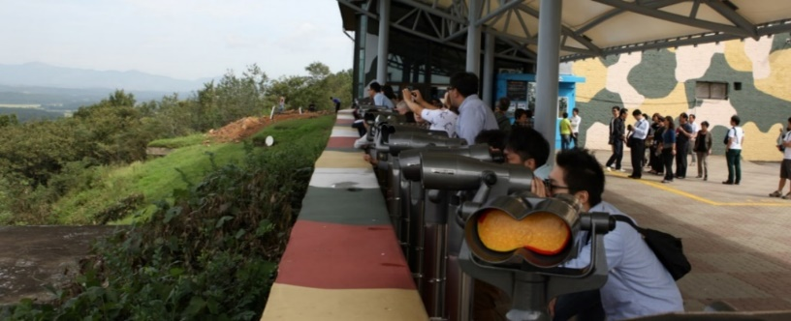 DMZ Tour

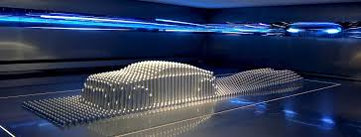 Hyundai Motorstudio Goyang
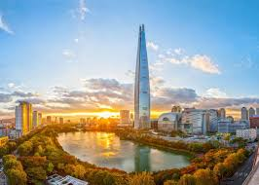 Lotte World Tower
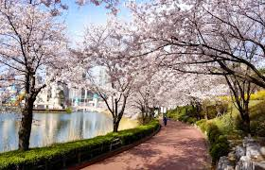 Seokchon Lake Cherry Blossom Festival
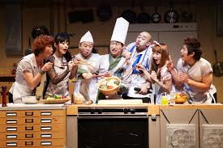 The Musical CHEF Show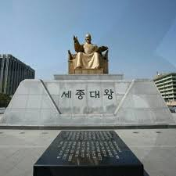 Sejong Story Exhibition Hall

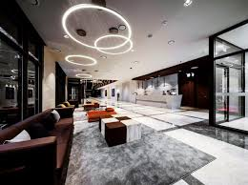 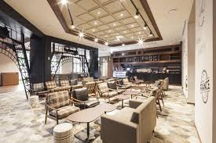 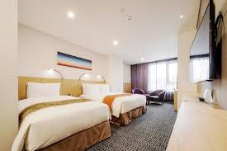 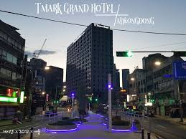Tmark Grand Hotel Myeongdong

